Assignment Submission Report

Name: Nico Natividad

Course / Cohort: 68

Assignment: Python Script "Dog Age Converted"

GitHub Repository Link: Nico-Natividad/intro-python

Evidence of Functionality

Code/Results:
- Screenshot of terminal output and assignment code
- 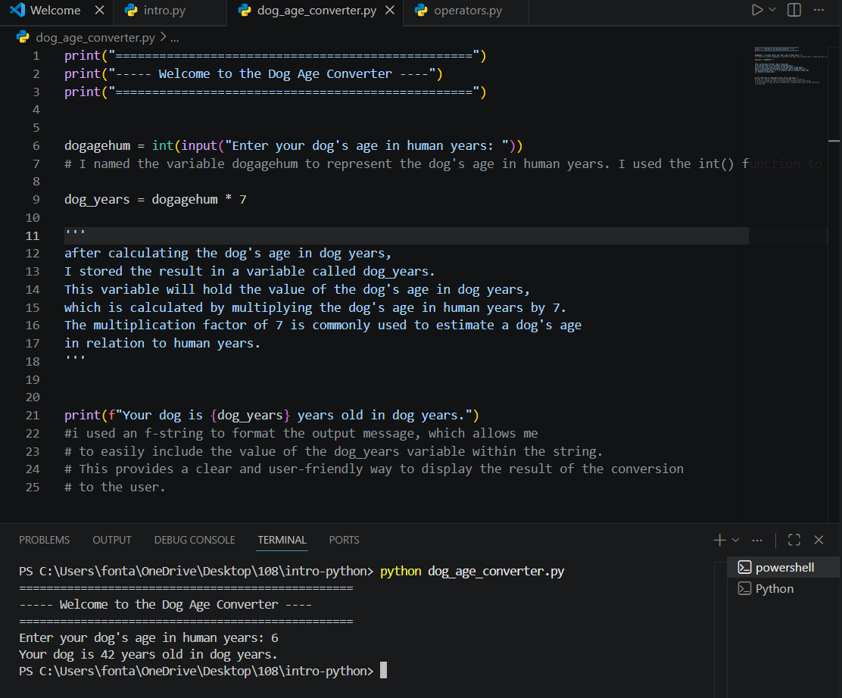

AI Disclosure (Required) – Highlight the one that applies
- I did not use AI
- I used AI for help
- AI generated parts of my code

